CR-05 - Goals and Outcomes
Progress the jurisdiction has made in carrying out its strategic plan and its action plan. 91.520(a)
This could be an overview that includes major initiatives and highlights that were proposed and executed throughout the program year.

Gastonia completed its fourth year in carrying out its 2020-24 Strategic Plan. The first order of business is to be able to conduct activities in a way that is:
1. Beneficial to the populace we serve
2. Ensures the safety of staff, citizens, contractors, and subrecipients
3. Providies services that are of the greatest need
Comparison of the proposed versus actual outcomes for each outcome measure submitted with the consolidated plan and explain, if applicable, why progress was not made toward meeting goals and objectives. 91.520(g)
Categories, priority levels, funding sources and amounts, outcomes/objectives, goal outcome indicators, units of measure, targets, actual outcomes/outputs, and percentage completed for each of the grantee’s program year goals.

Goal | Category | Source / Amount | Indicator | Unit of Measure | Expected – Strategic Plan | Actual – Strategic Plan | Percent Complete | Expected – Program Year | Actual – Program Year | Percent Complete
Demolition and Clearance | Non-Housing Community Development | CDBG: $ | Public Facility or Infrastructure Activities other than Low/Moderate Income Housing Benefit | Persons Assisted | 2500 | 0 | 0.00%
Fair Housing | Fair Housing | CDBG: $ | Public service activities other than Low/Moderate Income Housing Benefit | Persons Assisted | 1750 | 700 | 40.00% | 400 | 700 | 175.00%
Homeless Assistance and Services | Homeless | CDBG: $ / HOME: $29122 | Public service activities other than Low/Moderate Income Housing Benefit | Persons Assisted | 1750 | 5924 | 338.51% | 400 | 5924 | 1,481.00%
Homeless Assistance and Services | Homeless | CDBG: $ / HOME: $29122 | Homeless Person Overnight Shelter | Persons Assisted | 0 | 185 |  | 0 | 185
Homeless Assistance and Services | Homeless | CDBG: $ / HOME: $29122 | Overnight/Emergency Shelter/Transitional Housing Beds added | Beds | 0 | 0 |  | 0 | 0
Homeless Assistance and Services | Homeless | CDBG: $ / HOME: $29122 | Homelessness Prevention | Persons Assisted | 1000 | 0 | 0.00% | 242 | 0 | 0.00%
Program Administration | Administration | CDBG: $ / HOME: $ | Other | Other | 1 | 0 | 0.00% | 400 | 0 | 0.00%
Public Improvements | Non-Housing Community Development | CDBG: $ | Public Facility or Infrastructure Activities other than Low/Moderate Income Housing Benefit | Persons Assisted | 25000 | 3832 | 15.33% | 0 | 3832
Public Services | Public Services | CDBG: $ | Public service activities for Low/Moderate Income Housing Benefit | Households Assisted | 0 | 0
Safe and Decent Affordable Housing | Affordable Housing | CDBG: $ / HOME: $ | Rental units constructed | Household Housing Unit | 30 | 0 | 0.00%
Safe and Decent Affordable Housing | Affordable Housing | CDBG: $ / HOME: $ | Homeowner Housing Added | Household Housing Unit | 0 | 28 |  | 5 | 2 | 40.00%
Safe and Decent Affordable Housing | Affordable Housing | CDBG: $ / HOME: $ | Homeowner Housing Rehabilitated | Household Housing Unit | 50 | 27 | 54.00% | 9 | 5 | 55.56%
Safe and Decent Affordable Housing | Affordable Housing | CDBG: $ / HOME: $ | Direct Financial Assistance to Homebuyers | Households Assisted | 275 | 2 | 0.73% | 20 | 2 | 10.00%
Safe and Decent Affordable Housing | Affordable Housing | CDBG: $ / HOME: $ | Tenant-based rental assistance / Rapid Rehousing | Households Assisted | 250 | 9 | 3.60% | 5 | 5 | 100.00%
Safe and Decent Affordable Housing | Affordable Housing | CDBG: $ / HOME: $ | Homelessness Prevention | Persons Assisted | 0 | 0 |  | 25 | 0 | 0.00%
Safe and Decent Affordable Housing | Affordable Housing | CDBG: $ / HOME: $ | Other | Other | 0 | 0 |  | 400 | 0 | 0.00%
Section 108 Loan Program | Non-Housing Community Development | CDBG: $ | Other | Other | 0 | 0
Table 1 - Accomplishments – Program Year & Strategic Plan to Date

Assess how the jurisdiction’s use of funds, particularly CDBG, addresses the priorities and specific objectives identified in the plan, giving special attention to the highest priority activities identified.
In spite of the current market and in continuation of the prior year’s plan, the first ranking priority and largest share of CDBG and HOME Funds are targeted toward affordable housing. With Affordable Housing having many varying factors to include market volatility, staff’s efforts were directed toward how to best assist the needs of citizens in the low- to moderate income range. With affordable housing continuing to be a crisis across the country, staff's objective was to determine how to effectively use funds in a way that would have the greatest overall impact to the community.
The second highest ranking priority is Public Improvements followed by Program Administration and Homelessness Assistance and Services. The second largest portion of CDBG funds are used towards sustaining afforable housing by means of homeowner housing rehabilitation. To further support efforts to procure affordable housing for residents of the community, a large portion of HOME funds are channeled toward new construction and direct financial assistance to homebuyers.

CR-10 - Racial and Ethnic composition of families assisted
Describe the families assisted (including the racial and ethnic status of families assisted). 91.520(a)

 | CDBG | HOME
White | 3,305 | 1
Black or African American | 2,032 | 0
Asian | 6 | 0
American Indian or American Native | 42 | 0
Native Hawaiian or Other Pacific Islander | 5 | 0

Total | 5,390 | 1

Hispanic | 34 | 0
Not Hispanic | 5,356 | 1

Table 2 – Table of assistance to racial and ethnic populations by source of funds

Narrative
White individuals and households, along with Black or African American individuals and households, continue to be the largest demographic segments of the population served within Gastonia and Gaston County. During FY 2023-2024, the HOME Investment Partnerships Program served one household, which was White. The Community Development Block Grant (CDBG) Program assisted 61.3% White households and 37.7% Black or African American households.

CR-15 - Resources and Investments 91.520(a)
Identify the resources made available
Source of Funds | Source | Resources Made Available | Amount Expended During Program Year
CDBG | public - federal | 580,796 | 435,823
HOME | public - federal | 849,516 | 93,434
Table 3 - Resources Made Available

Narrative

Identify the geographic distribution and location of investments
Target Area | Planned Percentage of Allocation | Actual Percentage of Allocation | Narrative Description
Central Gastonia | 100
Gastonia Consortium
Table 4 – Identify the geographic distribution and location of investments

Narrative
For the Community Development Block Grant (CDBG) funds, the geographic distribution area is the corporate limits of Gastonia. Presently there are four (4) areas within the corporate limits of Gastonia and within Gaston County with large concentrations of racial/ethnic minorities and low-income families. The census tracts are listed as follows:
- 318.00
- 319.00
- 320.00
- 332.01
The largest concentration of African-Americans is within the Highland Community, specifically census tract 320.00. For the HOME Investment Partnership Program Funds, the geographic distribution area includes the corporate limits of Gastonia, Gaston County, and the corporate limits of Kings Mountain inclusive of the area within Cleveland County. Applicant homebuyers seeking housing assistance must reside in Gastonia, Belmont, Bessemer City, Cherryville, Cramerton, Dallas, Lowell, McAdenville, Mount Holly, Ranlo, Stanley, or in the unincorporated areas of Gaston County.
Leveraging
Explain how federal funds leveraged additional resources (private, state and local funds), including a description of how matching requirements were satisfied, as well as how any publicly owned land or property located within the jurisdiction that were used to address the needs identified in the plan.
$3.3 million leveraged for $300,000 of disbursed HOME funds for a Low-Income Housing Tax Credit (LIHTC) 78-unit senior housing project.

Fiscal Year Summary – HOME Match
1. Excess match from prior Federal fiscal year | 5,183,976
2. Match contributed during current Federal fiscal year | 3,373,054
3. Total match available for current Federal fiscal year (Line 1 plus Line 2) | 8,557,030
4. Match liability for current Federal fiscal year | 82,025
5. Excess match carried over to next Federal fiscal year (Line 3 minus Line 4) | 8,475,005
Table 5 – Fiscal Year Summary - HOME Match Report

Match Contribution for the Federal Fiscal Year
Project No. or Other ID | Date of Contribution | Cash  (non-Federal sources) | Foregone Taxes, Fees, Charges | Appraised Land/Real Property | Required Infrastructure | Site Preparation, Construction Materials, Donated labor | Bond Financing | Total Match
HG2881 | 09/26/2024 | 2,920,900 | 0 | 0 | 0 | 0 | 452,154 | 3,373,054
Table 6 – Match Contribution for the Federal Fiscal Year

HOME MBE/WBE report
Program Income – Enter the program amounts for the reporting period
Balance on hand at begin-ning of reporting period  $ | Amount received during reporting period  $ | Total amount expended during reporting period  $ | Amount expended for TBRA  $ | Balance on hand at end of reporting period  $
0 | 74,590 | 46,840 | 30,712 | 27,509
Table 7 – Program Income

Minority Business Enterprises and Women Business Enterprises – Indicate the number and dollar value of contracts for HOME projects completed during the reporting period

 | Total | Minority Business Enterprises |  |  |  | White Non-Hispanic
 | Total | Alaskan Native or American Indian | Asian or Pacific Islander | Black Non-Hispanic | Hispanic | White Non-Hispanic

Contracts
Dollar Amount | 400,000 | 0 | 0 | 0 | 0 | 400,000
Number | 1 | 0 | 0 | 0 | 0 | 1

Sub-Contracts
Number | 0 | 0 | 0 | 0 | 0 | 0
Dollar Amount | 0 | 0 | 0 | 0 | 0 | 0

 | Total | Women Business Enterprises | Male

Contracts
Dollar Amount | 0 | 0 | 0
Number | 0 | 0 | 0

Sub-Contracts
Number | 0 | 0 | 0
Dollar Amount | 0 | 0 | 0
Table 8 - Minority Business and Women Business Enterprises

Minority Owners of Rental Property – Indicate the number of HOME assisted rental property owners and the total amount of HOME funds in these rental properties assisted

 | Total | Minority Property Owners |  |  |  | White Non-Hispanic
 | Total | Alaskan Native or American Indian | Asian or Pacific Islander | Black Non-Hispanic | Hispanic | White Non-Hispanic
Number | 2 | 0 | 0 | 0 | 0 | 2
Dollar Amount | 41,830 | 0 | 0 | 0 | 0 | 41,830
Table 9 – Minority Owners of Rental Property

Relocation and Real Property Acquisition – Indicate the number of persons displaced, the cost of relocation payments, the number of parcels acquired, and the cost of acquisition

Parcels Acquired | 0 | 0
Businesses Displaced | 0 | 0
Nonprofit Organizations Displaced | 0 | 0
Households Temporarily Relocated, not Displaced | 0 | 0

Households Displaced | Total | Minority Property Enterprises |  |  |  | White Non-Hispanic
Households Displaced | Total | Alaskan Native or American Indian | Asian or Pacific Islander | Black Non-Hispanic | Hispanic | White Non-Hispanic
Number | 0 | 0 | 0 | 0 | 0 | 0
Cost | 0 | 0 | 0 | 0 | 0 | 0
Table 10 – Relocation and Real Property Acquisition

CR-20 - Affordable Housing 91.520(b)
Evaluation of the jurisdiction's progress in providing affordable housing, including the number and types of families served, the number of extremely low-income, low-income, moderate-income, and middle-income persons served.

 | One-Year Goal | Actual
Number of Homeless households to be provided affordable housing units | 242 | 0
Number of Non-Homeless households to be provided affordable housing units | 20 | 2
Number of Special-Needs households to be provided affordable housing units | 0 | 0
Total | 262 | 2
Table 11 – Number of Households

 | One-Year Goal | Actual
Number of households supported through Rental Assistance | 5 | 4
Number of households supported through The Production of New Units | 11 | 2
Number of households supported through Rehab of Existing Units | 9 | 5
Number of households supported through Acquisition of Existing Units | 0 | 0
Total | 25 | 11
Table 12 – Number of Households Supported

Discuss the difference between goals and outcomes and problems encountered in meeting these goals.
During the program year, the City of Gastonia supported 11 households as part of its housing initiatives. The City provided rental assistance to 4 households out of a target of 5, following a shift in program administration to focus on compliance improvements. In terms of housing production, the City completed 2 of the projected 11 new units, with the remaining units expected to be finished in the next program year. The City also rehabilitated 5 units, including one project that required extensive reconstruction, which affected the overall number of units completed. In addition, 2 non-homeless households benefited from down payment assistance, helping them achieve affordable homeownership.
Discuss how these outcomes will impact future annual action plans.
Future action plans will assess the FY2023 program data, funding allocations, and feedback received through citizen participation to more accurately project assistance numbers for each category.
During FY2023-2024, The Gastonia Electric Assistance Resource (GEAR), a City utility assistance program funded by general funds, assisted 10 very-low income households.
Include the number of extremely low-income, low-income, and moderate-income persons served by each activity where information on income by family size is required to determine the eligibility of the activity.

Number of Households Served | CDBG Actual | HOME Actual
Extremely Low-income | 1 | 0
Low-income | 2 | 1
Moderate-income | 0 | 0
Total | 3 | 1
Table 13 – Number of Households Served

Narrative Information

CR-25 - Homeless and Other Special Needs 91.220(d, e); 91.320(d, e); 91.520(c)
Evaluate the jurisdiction’s progress in meeting its specific objectives for reducing and ending homelessness through:
Reaching out to homeless persons (especially unsheltered persons) and assessing their individual needs
The Gaston/Lincoln/Cleveland Continuum of Care (CoC) continues its efforts to combat homelessness through coordinated outreach focused on unsheltered individuals, aligned with the goals set forth in its Strategic Plan and Coordinated Entry Policy. Guided by the principles in its Written Program Standards and Standard Operating Procedures (SOP), the CoC's outreach teams engage with homeless individuals across the area, utilizing the Vulnerability Index-Service Prioritization Decision Assistance Tool (VI-SPDAT) to assess needs and prioritize housing placement. The Continuum of Care relys on collaborations with various agencies, to further aid in comprehensive services, including healthcare, mental health, and substance abuse treatment, as emphasized in the SOP’s cross-sector partnership approach. Regular training and capacity-building initiatives, informed by the Strategic Plan, ensure that outreach workers have the opportunity to become well-equipped with the latest best practices, such as trauma-informed care and cultural competency. These efforts enhance the CoC’s ability to reach and support the most vulnerable populations while aligning with the broader objectives of reducing homelessness and increasing housing stability across the jurisdiction.
The January 23, 2024 Point-In-Time (PIT) Count/Survey was conducted. This survey allowed the GLC CoC to best determine where services and outreach are lacking and develop a better course of action to address future efforts. The 2024 PIT Count identified 451 homeless persons, of which 216 were unsheltered. Of the 235 sheltered persons, 212 were in Emergency Shelters and 23 in Transitional Shelters. Full details of the count are noted in the charts below.
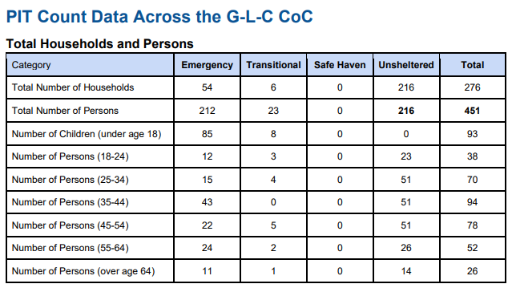
2024 Point in Time Count
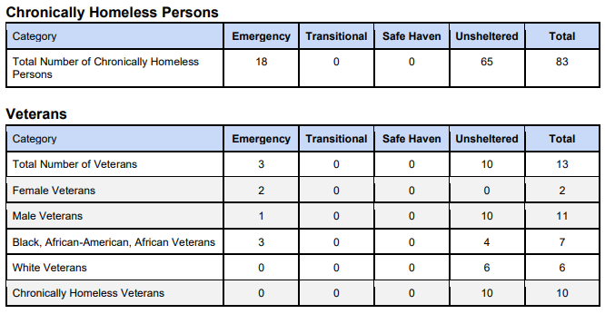
2024 Point in Time Count- Chronically Homeless ÿ Homeless Veterans
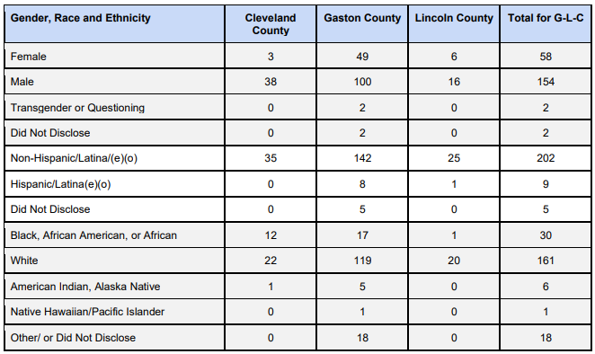
2024 Point in Time Count- Demographics by County
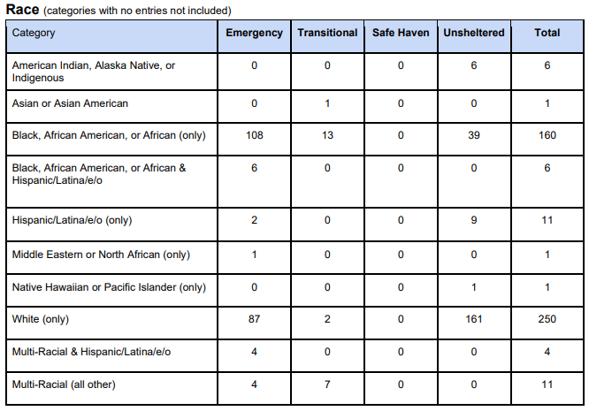
2024 Point in Time Count- Race by Housing Status
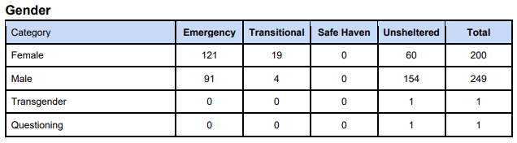
2024 Point in Time Count- Gender by Housing Status
Addressing the emergency shelter and transitional housing needs of homeless persons
The Gaston Lincoln Cleveland (G-L-C) Continuum of Care (CoC) continues to adapt its strategies to address emergency shelter and transitional housing needs of homeless individuals and families. The Salvation Army announced that it would cease emergency shelter operations as of August 31, 2024. The community is actively exploring alternative emergency shelter options while the Salvation Army shifts its focus to Rapid Re-Housing and Food Assistance. The CoC remains committed to providing transitional housing through existing programs and is working closely with partner agencies to ensure continued access to essential services. By reinforcing its coordinated entry system, ensuring that all agencies are trained in HMIS, and aligning with the policies outlined in the CoC’s Written Program Standards and Standard Operating Procedures, the G-L-C CoC strives to enhance access to mainstream resources and support the self-sufficiency of those experiencing homelessness. These efforts reflect the ongoing dedication to meeting the community's evolving needs and to comprehensively address homelessness.
Helping low-income individuals and families avoid becoming homeless, especially extremely low-income individuals and families and those who are: likely to become homeless after being discharged from publicly funded institutions and systems of care (such as health care facilities, mental health facilities, foster care and other youth facilities, and corrections programs and institutions); and, receiving assistance from public or private agencies that address housing, health, social services, employment, education, or youth needs
The Gaston/Lincoln/Cleveland Continuum of Care (CoC) works to enhance efforts to prevent homelessness among low-income individuals and families, particularly those at risk of becoming homeless after discharge from publicly funded institutions such as healthcare facilities, mental health facilities, foster care, and correctional programs. Guided by its Strategic Plan and Coordinated Entry Policy, the CoC is in the process of refining its approach to ensure that CoC agencies and staff are properly trained and equipped to support these vulnerable populations. The CoC recognizes the challenges in transitioning individuals smoothly from institutions to stable housing, especially given the limited resources and availability of affordable permanent supportive housing. However, by strengthening its Coordinated Entry System and fostering cross-sector collaborations, the CoC aims to gradually improve access to essential services—such as health care, employment, and social services—that can help stabilize individuals and families at risk. While these efforts are still in development, they are expected to contribute positively over time to reducing the risk of homelessness for those most vulnerable in the community.
Helping homeless persons (especially chronically homeless individuals and families, families with children, veterans and their families, and unaccompanied youth) make the transition to permanent housing and independent living, including shortening the period of time that individuals and families experience homelessness, facilitating access for homeless individuals and families to affordable housing units, and preventing individuals and families who were recently homeless from becoming homeless again
The City of Gastonia continues its collaborative efforts with the Gaston-Lincoln-Cleveland Continuum of Care (CoC) to assist homeless individuals and families. There is a particular focus on chronically homeless individuals and families, families with children, veterans and their families, and unaccompanied youth. Transitioning homeless individuals and families to permanent housing and independent living remains a significant challenge, particularly given the limited availability of affordable housing units. The length of time individuals and families experience homelessness is a persistent concern, as is the risk of returning to homelessness after securing housing. The CoC works to address these issues by refining its coordinated strategies and strengthening partnerships, but it recognizes that the scarcity of resources and affordable housing options makes this an ongoing struggle. Despite challenges, the community remains committed to reducing homelessness and supporting vulnerable populations in their journey toward stability and self-sufficiency.

CR-30 - Public Housing 91.220(h); 91.320(j)
Actions taken to address the needs of public housing
The Gastonia Housing Authority (GHA) provides permanent housing for very low and extremely low income families through two Section 8 programs and applicants can apply for one or both of the programs, providing the waiting lists are open.
- The Housing Choice Voucher (HCV) Program
- The Project-Based Voucher (PBV) Program
Applicants can apply for one or both of the programs, provided the waiting lists are open.
HCV provides opportunties to qualified applicants that allow families to locate affordable housing throughout Gaston County. As of August 2024, the waitlist for HCV’s is currently at 4,995 households. GHA has 1,786 Housing Choice Vouchers (HCV); 100 are prioritized for Non-Elderly Disabled (NED) individuals. Additionally, GHA operates 399 Project-Based Vouchers (PBV) units through the Rental Assistance Demonstration (RAD) program.
The Emergency Housing Voucher (EHV) program, which provided 37 vouchers to prioritize individuals and families experiencing homelessness, at risk of homelessness, or those fleeing domestic violence, was a temporary program. No new EHVs were issued after September 2023, and as participants exit the program, the vouchers are not reissued. EHV Vouchers have been available for the past then years; no future funding is allocated for vouchers. Although the program will end, GHA remains committed to ensuring that other housing resources, such as the HCV and NED programs, are effectively managed to meet the needs of Gaston County residents.
Project-Based Vouchers (PBV) provide assistance at specific apartment communities in Gaston County. Below are a list of the communities that have project-based voucher assistance provided by the Gastonia Housing Authority.
- Cameron Courts
- Weldon Heights
- Mountain View
- Linwood Terrace (for seniors, 62 and older)
The Belmont Housing Authority provides permanent housing for eligible low-income elderly individuals and persons with disabilities through two Public Housing Properties.
- Flowers Court
- Myrtle Terrace
Actions taken to encourage public housing residents to become more involved in management and participate in homeownership
The City of Gastonia offers a Down Payment Assistance Program, which includes a required Homebuyers Education Class to prepare participants for successful homeownership. GHA has access to this information and is encouraged to actively promote these opportunities, connecting public housing residents with the resources needed to pursue homeownership.
GHA continues to explore and implement housing developments across Gastonia and neighboring townships, as reflected in recent multi-family housing projects funded through revenue bonds. These projects, including Fairhaven Place and The Lofts at Hudson, demonstrate GHA’s commitment to expanding affordable housing options for families and seniors.
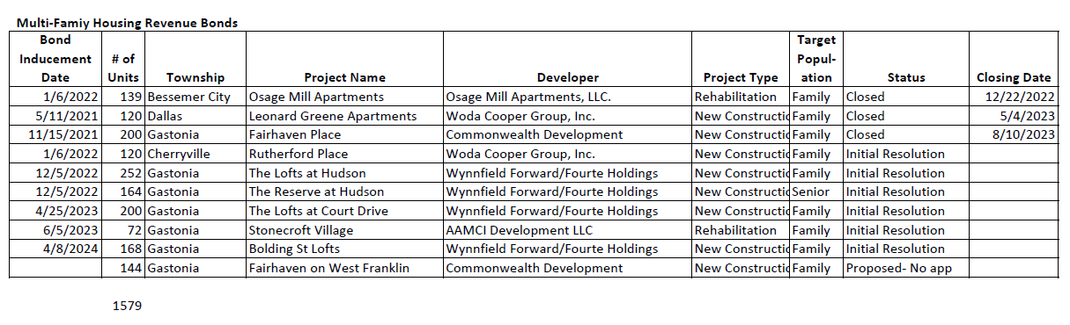
Gastonia Housing Authority Multi-Family Housing Revenue Bonds as of August 2024
Actions taken to provide assistance to troubled PHAs
Neither the Gastonia Housing Authority nor the Belmont Housing Authority are not considered troubled Public Housing Authority (PHA), therefore this category does not apply.

CR-35 - Other Actions 91.220(j)-(k); 91.320(i)-(j)
Actions taken to remove or ameliorate the negative effects of public policies that serve as barriers to affordable housing such as land use controls, tax policies affecting land, zoning ordinances, building codes, fees and charges, growth limitations, and policies affecting the return on residential investment. 91.220 (j); 91.320 (i)
During the program year, the City of Gastonia advanced its efforts to remove barriers to affordable housing by adopting the Affordable Housing Plan. This plan outlines strategic actions to enhance affordable housing options in the community. One of the initial steps taken was to begin the establishment of an Affordable Housing Advisory Board, which was recebtly assembled. Additionally, the City will review and address impediments to fair housing identified in the Analysis of Impediments to Fair Housing Choice. These efforts highlight the City’s proactive approach to fostering a more inclusive and accessible housing environment for all residents.
Actions taken to address obstacles to meeting underserved needs. 91.220(k); 91.320(j)
The City of Gastonia and Gaston Association of Realtors hosted a Fair Housing Event in April 2024. 83 persons participated in the event that highlighted the history of Fair Housing and local impacts, and an account from an individuals personal experience affected by Fair Housing violations. The event also included a four-hour NC Real Estate Continuing Education Elective Course titled "Bias Override: Overcoming Barriers to Fair Housing." This course provided real estate professionals with critical training on recognizing and overcoming biases that can hinder fair housing efforts however, was open to all interested persons.
City General Funds are used to create an assistance fund that helps with customer utility costs. This is called the Gastonia Electric Assistance Resource (GEAR) Program. Very low and low-income families that meet program requirements and apply are eligible to receive a monthly stipend which is applied to the utility balance of $25-$35.
Actions taken to reduce lead-based paint hazards. 91.220(k); 91.320(j)
The City currently assesses pre-1978 housing for the homebuyers and the owner-occupied rehabilitation program. Pre-and post testing and assessments are conducted as needed. In addition, efforts are made to educate program participants on the hazards of lead by providing resource materials at the time of program application.
Actions taken to reduce the number of poverty-level families. 91.220(k); 91.320(j)
During the program year, the City of Gastonia adopted the Affordable Housing Plan as a key step toward addressing the needs of poverty-level families. As part of this effort, the City established an Affordable Housing Advisory Board to guide future implementation of the plan's initiatives. The City also aims to promote economic mobility for low-income families by encouraging participation in housing counseling and homebuyer assistance programs. These actions are designed to help provide more stable, affordable housing options, which can assist families in moving toward greater economic stability over time.
Actions taken to develop institutional structure. 91.220(k); 91.320(j)
The City of Gastonia continues its efforts to develop partnerships with Community Organizations, Public Agencies, sub-recipients, and contractors. During FY2023-24, the City of Gastonia focused on the strengthening its institutional structure through two key partnerships: the Community Housing Development Organization (CHDO) and the Lead Agency for the Continuum of Care. Belmont Community Development Corporation remains the designated CHDO for the ongoing project on Norment Ave. in Gastonia, with the City providing ongoing technical assistance to support the successful execution of the project. Additionally, HealthNet Gaston continues to serve as the Lead Agency for the Continuum of Care, and the City of Gastonia is actively offering technical assistance as needed to support the ongoing structural improvement and effectiveness of the Continuum of Care. These collaborations are critical in enhancing the capacity and coordination of the organizations involved in housing and homelessness services within the community.
Actions taken to enhance coordination between public and private housing and social service agencies. 91.220(k); 91.320(j)
During the program year, the City of Gastonia continued to strengthen its partnership with HealthNet Gaston, the lead agency for the Gaston-Lincoln-Cleveland Continuum of Care (CoC). HealthNet Gaston has been instrumental in coordinating efforts to address homelessness in the region, bringing together public and private housing and social service agencies to provide comprehensive support to those in need. The City collaborates closely with HealthNet Gaston to ensure that CoC initiatives are effectively implemented, facilitating communication and coordination across agencies to improve service delivery and outcomes for vulnerable populations.
Identify actions taken to overcome the effects of any impediments identified in the jurisdictions analysis of impediments to fair housing choice. 91.520(a)
In the program year, the City of Gastonia took several actions to address the barriers identified in the May 2019 Analysis of Impediments to Fair Housing. To address the need for expanded fair housing education, the City partnered with the Gaston Association of Realtors for a Fair Housing event with 83 participants, providing education on Fair Housing and bias in real estate. To combat racial disparities in access to homeownership, the City held six Homebuyer Education Classes with 91 participants, 60 of whom were Black or African American, and supported three homeownership opportunities by constructing two new homes and reconstructing one in a Historic African American Community with a population that is 91% African American.
Additionally, the City also continues to provide a Fair Housing Phone Line that is utilized to provide information to persons who feel they have been denied the rental or sale of housing because of race, sex, color, religion or national origin, family status or disability. Consumers often present other housing questions that do not relate to discrimination and are able to receive referrals to other resources like legal aid, non-profits, etc. On average, the Fair Housing line receives approximately 34 calls per month.
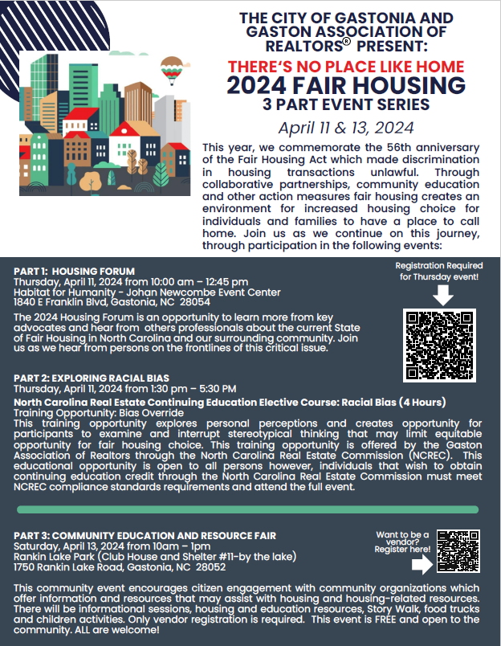
2024 No Place Like Home Fair Housing Flyer
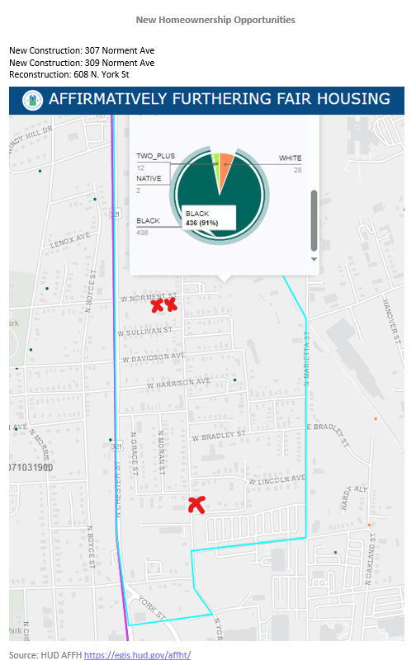
Increased Homeownership Opportunities

CR-40 - Monitoring 91.220 and 91.230
Describe the standards and procedures used to monitor activities carried out in furtherance of the plan and used to ensure long-term compliance with requirements of the programs involved, including minority business outreach and the comprehensive planning requirements

Upon completion and close-out of an activity, a monitoring case file is established that denotes the affordability period and the compliance requirements for the activity. Staff monitors updates as released by HUD and changes to regulations to further remain up to date with compliance. To ensure long-term compliance, the project is added to the monitoring schedule and projects are monitored as required. All activities are conducted in accordance with program regulations and current monitoring policies. The City of Gastonia has a structured set of standards and procedures to oversee activities aligned with its strategic plan and ensure ongoing compliance with program requirements. This approach involves routine program assessments, thorough documentation, and diligent progress tracking.
Minority business outreach efforts include support and intentional inclusion of Minority Business Enterprise (MBE) and small business in the competitive bid process. To date the City of Gastonia does not have a minority recruitment program in place. Gaston County government has implemented a program to conduct outreach to miniority businesses. The City of Gastonia supports Gaston County government's programming efforts where possible.
Comprehensive planning requirements include intermittent reviews of the Consolidated Plan in preparing for Annual Plan preparation in coorelation with current City's strategic plan.
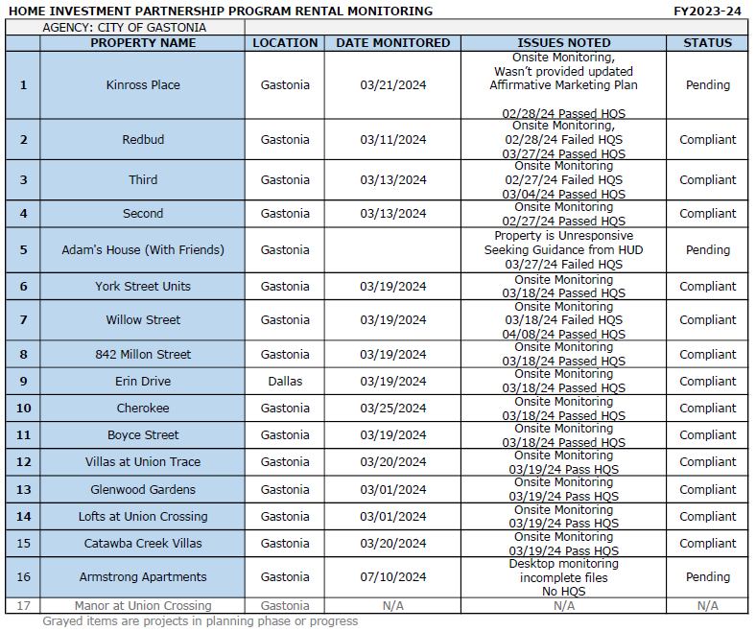
HOME Rental Monitoring July 1, 2023 - June 30, 2024
Narrative
As shown in the FY2023-24 HOME Investment Partnership Program rental monitoring, the majority of properties have been found compliant after inspection. Efforts to resolve pending issues are ongoing, with Kinross Place addressing staffing challenges, Adams House awaiting HUD guidance, and Armstrong Apartments working to correct submission errors. These properties are actively being monitored to ensure compliance, while several properties with minor inspection failures have already addressed and resolved these issues.

Citizen Participation Plan 91.105(d); 91.115(d)
Describe the efforts to provide citizens with reasonable notice and an opportunity to comment on performance reports.
Efforts to provide citizens with reasonable notice and an opportunity to comment on performance reports are done in accordance with the current Citizen Participation Plan,revised 2019. A 30-day public comment period is established for both the Annual Action Plan and the Consolidated Annual Performance Evaluation Report. A minimum 10-day advance notice is published notifying citizens of the opportunity to participate, review and/or comment along with the date, time, and location to review the plans and/or attend the public hearings. Notices are published in the local newspaper and on the City's website. In addition, the Citizens Advisory Board consists of 1 member selected by the Council to represent each of the City’s six wards or other areas deemed appropriate by the Council. Additionally, there shall be two at-large members appointed by Gaston County Commission to represent the county’s unincorporated areas. Board members are extended the opportunity to review proposed plans and activities and comment accordingly. The board meets quarterly and is notified of public hearings for all plans.
Staff makes efforts to notify communities of public comment opportunities through placement on the City’s website and social media pages. The City of Gastonia also has a program which has established Recognized Communities (RC). A monthly newsletter is published and provided to the community that is inclusive of citizen participation opportunities.

CR-45 - CDBG 91.520(c)
Specify the nature of, and reasons for, any changes in the jurisdiction’s program objectives and indications of how the jurisdiction would change its programs as a result of its experiences.
The housing market has been challenging; the market will be continuously monitored, and program objectives will be adjusted accordingly.
Does this Jurisdiction have any open Brownfields Economic Development Initiative (BEDI) grants?
No
[BEDI grantees] Describe accomplishments and program outcomes during the last year.

CR-50 - HOME 24 CFR 91.520(d)
Include the results of on-site inspections of affordable rental housing assisted under the program to determine compliance with housing codes and other applicable regulations
Please list those projects that should have been inspected on-site this program year based upon the schedule in 24 CFR §92.504(d). Indicate which of these were inspected and a summary of issues that were detected during the inspection. For those that were not inspected, please indicate the reason and how you will remedy the situation.
The FY2023-24 is shown below and in section CR-40 Monitoring. Although requirements are specified for the HOME Program, Gastonia chooses to adhere to a more stringent monitoring schedule by reviewing all properties annually. This method ensures that units remain compliant and any issues are addressed in a timely fashion without a substantial period of time passing before staff is aware of the issue.
During the FY 2023-24 monitoring process, all HOME projects were found to be in compliance, with the exception of three. Staff is actively working with the recipients of these funds to address the non-compliance issues. Additionally, as detailed below, four properties failed the initial HQS Inspection due to "non-functional components" and/or "failed components." Staff provides technical support and guidance as needed, and will take enforcement actions to ensure compliance.
Staff continues to work with the funded recipients to rectify the non-compliance issues. Staff will provide technical assistance and guidance to resolve the matter(s) through enforcement as necessary.
Inspections
Provide an assessment of the jurisdiction's affirmative marketing actions for HOME units. 24 CFR 91.520(e) and 24 CFR 92.351(a)
The City of Gastonia remains committed to supporting and implementing affirmative marketing efforts for all HOME-assisted units, ensuring that fair and equal housing opportunities are accessible to all individuals, regardless of race, color, national origin, religion, sex, familial status, or disability. The City's affirmative marketing plan continues to focus on reaching both minority and non-minority groups that are least likely to apply for occupancy.
To achieve this, the City actively promotes transparency in its housing activities by disseminating information through various channels, including social media, its official website, and organized community groups such as churches and neighborhood associations. These efforts ensure that information about available housing opportunities reaches a broad and diverse audience, particularly those who may face barriers to accessing housing.
These ongoing efforts reflect the City of Gastonia's dedication to creating a housing environment that is inclusive and equitable, providing equal access to housing opportunities for all members of the community.
Refer to IDIS reports to describe the amount and use of program income for projects, including the number of projects and owner and tenant characteristics
During FY 2023-24, $30,712 of the HOME program income was spent on Tenant Based Rental Assistance (TBRA). Of the families receiving assistance through TBRA, three families identified their race as "Black or African American", one family identified their race as "White.”One family identified "Hispanic" as their ethnicity. Four of the families receiving assistance through TBRA were within 0-30% of the AMI.
Describe other actions taken to foster and maintain affordable housing. 24 CFR 91.220(k) (STATES ONLY: Including the coordination of LIHTC with the development of affordable housing). 24 CFR 91.320(j)
N/A

CR-58 – Section 3
Identify the number of individuals assisted and the types of assistance provided

Total Labor Hours | CDBG | HOME | ESG | HOPWA | HTF
Total Number of Activities | 2 | 3 | 0 | 0 | 0
Total Labor Hours | 1,814 | 44,410
Total Section 3 Worker Hours | 167 | 10,061
Total Targeted Section 3 Worker Hours | 0 | 1,556
Table 15 – Total Labor Hours

Qualitative Efforts - Number of Activities by Program | CDBG | HOME | ESG | HOPWA | HTF
Outreach efforts to generate job applicants who are Public Housing Targeted Workers |  | 1
Outreach efforts to generate job applicants who are Other Funding Targeted Workers. | 2 | 1
Direct, on-the job training (including apprenticeships).
Indirect training such as arranging for, contracting for, or paying tuition for, off-site training.
Technical assistance to help Section 3 workers compete for jobs (e.g., resume assistance, coaching).
Outreach efforts to identify and secure bids from Section 3 business concerns. |  | 1
Technical assistance to help Section 3 business concerns understand and bid on contracts. |  | 1
Division of contracts into smaller jobs to facilitate participation by Section 3 business concerns.
Provided or connected residents with assistance in seeking employment including: drafting resumes,preparing for interviews, finding job opportunities, connecting residents to job placement services.
Held one or more job fairs.
Provided or connected residents with supportive services that can provide direct services or referrals.
Provided or connected residents with supportive services that provide one or more of the following: work readiness health screenings, interview clothing, uniforms, test fees, transportation.
Assisted residents with finding child care.
Assisted residents to apply for, or attend community college or a four year educational institution.
Assisted residents to apply for, or attend vocational/technical training. |  | 1
Assisted residents to obtain financial literacy training and/or coaching.
Bonding assistance, guaranties, or other efforts to support viable bids from Section 3 business concerns.
Provided or connected residents with training on computer use or online technologies.
Promoting the use of a business registry designed to create opportunities for disadvantaged and small businesses.
Outreach, engagement, or referrals with the state one-stop system, as designed in Section 121(e)(2) of the Workforce Innovation and Opportunity Act.
Other.
Table 16 – Qualitative Efforts - Number of Activities by Program

Narrative
During FY23, HOME funds supported the construction of one multi-family housing development and the completion of two single-family homes through the Community Housing Development Organization (CHDO). This resulted in a total of 44,410 labor hours for HOME-funded projects, including 10,061 hours from Section 3 workers and 1,556 hours from Targeted Section 3 workers.
Additionally, CDBG funds were utilized to complete two infrastructure projects, which included the construction of two park shelters and a restroom at one park, as well as a bathroom at another park. CDBG projects accounted for 1,814 labor hours, of which 167 hours were contributed by Section 3 workers.

Attachment
FY2023-24 CAPER- Affidavit
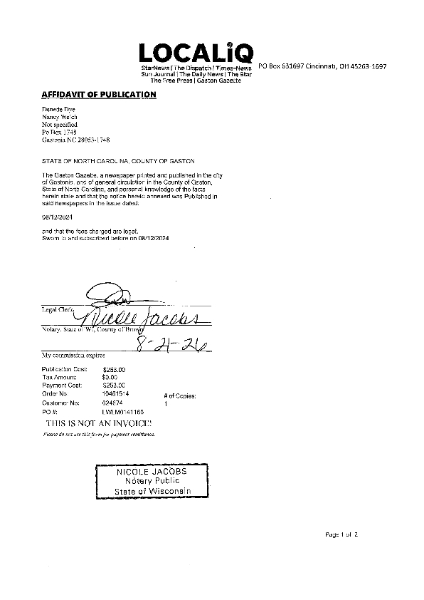
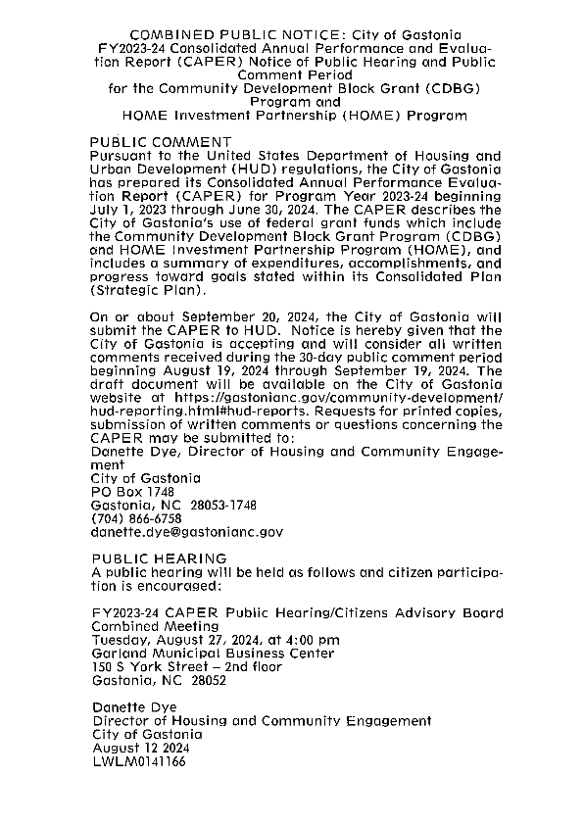

FY2023-24 CAPER- Public Comments
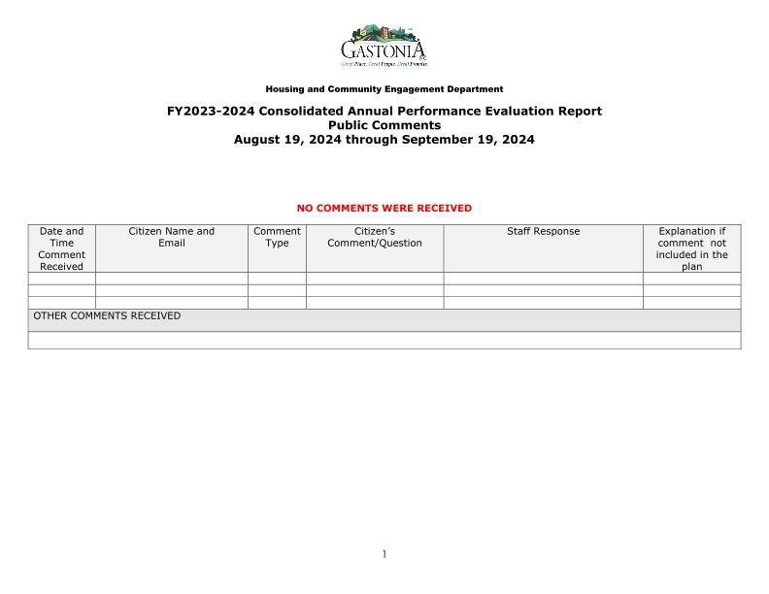
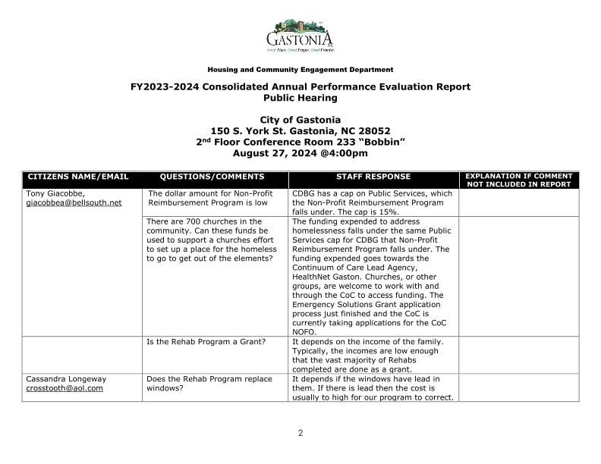
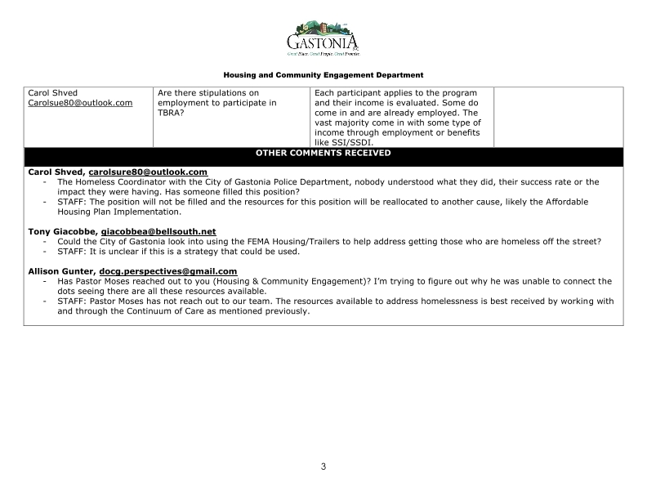

FY2023-24 CAPER- Certifications
