CR-05 - Goals and Outcomes
Progress the jurisdiction has made in carrying out its strategic plan and its action plan. 91.520(a)
This could be an overview that includes major initiatives and highlights that were proposed and executed throughout the program year.

The City of Gastonia has made use of HUD-issued grants for assisting low to moderate income families with rehabilitating homes with dilapidated core systems (flooring, roofing, HVAC, electrical and plumbing). The City has also utilized funding set aside from previous years to provide funding for a Community Housing Development Organization (CHDO) to construct two new homes which will be utilized for affordable housing opportunities for citizens of Gastonia. With use of CDBG-CV (Covid Relief Funding) , the City has made efforts in the planning and implementation of shelters at the a community recreation facility and a park. Grants funds were also contributed toward the construction of a multi-family housing facility. Of the 66 units constructed 4 of these will be utilized to assist low-to-moderate income households.
Comparison of the proposed versus actual outcomes for each outcome measure submitted with the consolidated plan and explain, if applicable, why progress was not made toward meeting goals and objectives. 91.520(g)
Categories, priority levels, funding sources and amounts, outcomes/objectives, goal outcome indicators, units of measure, targets, actual outcomes/outputs, and percentage completed for each of the grantee’s program year goals.

Goal | Category | Source / Amount | Indicator | Unit of Measure | Expected – Strategic Plan | Actual – Strategic Plan | Percent Complete | Expected – Program Year | Actual – Program Year | Percent Complete
Demolition and Clearance | Non-Housing Community Development | CDBG: $ | Public Facility or Infrastructure Activities other than Low/Moderate Income Housing Benefit | Persons Assisted | 2500 | 0 | 0.00%
Fair Housing | Fair Housing | CDBG: $ | Public service activities other than Low/Moderate Income Housing Benefit | Persons Assisted | 1750 | 400 | 22.86% | 400 | 400 | 100.00%
Homeless Assistance and Services | Homeless | CDBG: $ | Public service activities other than Low/Moderate Income Housing Benefit | Persons Assisted | 1750 | 6765 | 386.57% | 400 | 6765 | 1,691.25%
Homeless Assistance and Services | Homeless | CDBG: $ | Homeless Person Overnight Shelter | Persons Assisted | 0 | 0 |  | 0 | 0
Homeless Assistance and Services | Homeless | CDBG: $ | Overnight/Emergency Shelter/Transitional Housing Beds added | Beds | 0 | 0 |  | 0 | 0
Homeless Assistance and Services | Homeless | CDBG: $ | Homelessness Prevention | Persons Assisted | 1000 | 0 | 0.00% | 242 | 0 | 0.00%
Program Administration | Administration | CDBG: $ / HOME: $ | Other | Other | 1 | 0 | 0.00% | 1 | 0 | 0.00%
Public Improvements | Non-Housing Community Development | CDBG: $ | Public Facility or Infrastructure Activities other than Low/Moderate Income Housing Benefit | Persons Assisted | 25000 | 0 | 0.00% | 7500 | 0 | 0.00%
Public Services | Public Services | CDBG: $ | Public service activities for Low/Moderate Income Housing Benefit | Households Assisted | 0 | 0
Safe and Decent Affordable Housing | Affordable Housing | CDBG: $ / HOME: $ | Rental units constructed | Household Housing Unit | 30 | 0 | 0.00% | 7 | 0 | 0.00%
Safe and Decent Affordable Housing | Affordable Housing | CDBG: $ / HOME: $ | Homeowner Housing Added | Household Housing Unit | 0 | 1 |  | 0 | 1
Safe and Decent Affordable Housing | Affordable Housing | CDBG: $ / HOME: $ | Homeowner Housing Rehabilitated | Household Housing Unit | 50 | 17 | 34.00% | 10 | 17 | 170.00%
Safe and Decent Affordable Housing | Affordable Housing | CDBG: $ / HOME: $ | Direct Financial Assistance to Homebuyers | Households Assisted | 275 | 0 | 0.00% | 25 | 0 | 0.00%
Safe and Decent Affordable Housing | Affordable Housing | CDBG: $ / HOME: $ | Tenant-based rental assistance / Rapid Rehousing | Households Assisted | 250 | 0 | 0.00% | 60 | 0 | 0.00%
Section 108 Loan Program | Non-Housing Community Development | CDBG: $ | Other | Other | 0 | 0
Table 1 - Accomplishments – Program Year & Strategic Plan to Date

Assess how the jurisdiction’s use of funds, particularly CDBG, addresses the priorities and specific objectives identified in the plan, giving special attention to the highest priority activities identified.

CR-10 - Racial and Ethnic composition of families assisted
Describe the families assisted (including the racial and ethnic status of families assisted). 91.520(a)

 | CDBG | HOME
White | 3,266 | 25
Black or African American | 2,267 | 38
Asian | 4 | 5
American Indian or American Native | 34 | 0
Native Hawaiian or Other Pacific Islander | 4 | 0

Total | 5,575 | 68

Hispanic | 719 | 0
Not Hispanic | 4,856 | 68

Table 2 – Table of assistance to racial and ethnic populations by source of funds

Narrative
White individual and households and Black or African American individuals and households continue to be the largest demographic segments of the population served within Gastonia and Gaston County. During FY 2022-2023, the largest percentage of populations assisted were Black or African American households at 55.8% and White households at 36.7% through use of the HOME Investment Partnerships Program. The Community Development Block Grant (CDBG) Program, 48.09% of the persons assisted were Black/African American and 50.35% of the persons assisted were White.

CR-15 - Resources and Investments 91.520(a)
Identify the resources made available
Source of Funds | Source | Resources Made Available | Amount Expended During Program Year
CDBG | public - federal | 646,964 | 546,547
HOME | public - federal | 851,616 | 111,604
Table 3 - Resources Made Available

Narrative

Identify the geographic distribution and location of investments
Target Area | Planned Percentage of Allocation | Actual Percentage of Allocation | Narrative Description
Central Gastonia | 100
Table 4 – Identify the geographic distribution and location of investments

Narrative

Leveraging
Explain how federal funds leveraged additional resources (private, state and local funds), including a description of how matching requirements were satisfied, as well as how any publicly owned land or property located within the jurisdiction that were used to address the needs identified in the plan.
Additional federal funds were leveraged though down payment assistance activities. The local lending institutions provide permanent financing to program applicants and provide leverage through waived bank fees. The City continues to work with mortgage lenders in the creation and implementation of their CRA Affordable Housing Programs. Match requirements were met and satisifed homebuyer activities.

Fiscal Year Summary – HOME Match
1. Excess match from prior Federal fiscal year | 5,146,476
2. Match contributed during current Federal fiscal year | 37,500
3. Total match available for current Federal fiscal year (Line 1 plus Line 2) | 5,183,976
4. Match liability for current Federal fiscal year | 0
5. Excess match carried over to next Federal fiscal year (Line 3 minus Line 4) | 5,183,976
Table 5 – Fiscal Year Summary - HOME Match Report

Match Contribution for the Federal Fiscal Year
Project No. or Other ID | Date of Contribution | Cash  (non-Federal sources) | Foregone Taxes, Fees, Charges | Appraised Land/Real Property | Required Infrastructure | Site Preparation, Construction Materials, Donated labor | Bond Financing | Total Match
HG2818 | 03/03/2023 | 0 | 37,500 | 0 | 0 | 0 | 0 | 37,500
Table 6 – Match Contribution for the Federal Fiscal Year

HOME MBE/WBE report
Program Income – Enter the program amounts for the reporting period
Balance on hand at begin-ning of reporting period  $ | Amount received during reporting period  $ | Total amount expended during reporting period  $ | Amount expended for TBRA  $ | Balance on hand at end of reporting period  $
8,897 | 35,226 | 47,936 | 35,196 | 0
Table 7 – Program Income

Minority Business Enterprises and Women Business Enterprises – Indicate the number and dollar value of contracts for HOME projects completed during the reporting period

 | Total | Minority Business Enterprises |  |  |  | White Non-Hispanic
 | Total | Alaskan Native or American Indian | Asian or Pacific Islander | Black Non-Hispanic | Hispanic | White Non-Hispanic

Contracts
Dollar Amount | 876,456 | 0 | 0 | 576,456 | 0 | 300,000
Number | 2 | 0 | 0 | 1 | 0 | 1

Sub-Contracts
Number | 0 | 0 | 0 | 0 | 0 | 0
Dollar Amount | 0 | 0 | 0 | 0 | 0 | 0

 | Total | Women Business Enterprises | Male

Contracts
Dollar Amount | 876,456 | 0 | 876,456
Number | 2 | 0 | 2

Sub-Contracts
Number | 0 | 0 | 0
Dollar Amount | 0 | 0 | 0
Table 8 - Minority Business and Women Business Enterprises

Minority Owners of Rental Property – Indicate the number of HOME assisted rental property owners and the total amount of HOME funds in these rental properties assisted

 | Total | Minority Property Owners |  |  |  | White Non-Hispanic
 | Total | Alaskan Native or American Indian | Asian or Pacific Islander | Black Non-Hispanic | Hispanic | White Non-Hispanic
Number | 5 | 0 | 0 | 2 | 0 | 3
Dollar Amount | 44,539 | 0 | 0 | 9,678 | 0 | 34,862
Table 9 – Minority Owners of Rental Property

Relocation and Real Property Acquisition – Indicate the number of persons displaced, the cost of relocation payments, the number of parcels acquired, and the cost of acquisition

Parcels Acquired | 0 | 0
Businesses Displaced | 0 | 0
Nonprofit Organizations Displaced | 0 | 0
Households Temporarily Relocated, not Displaced | 0 | 0

Households Displaced | Total | Minority Property Enterprises |  |  |  | White Non-Hispanic
Households Displaced | Total | Alaskan Native or American Indian | Asian or Pacific Islander | Black Non-Hispanic | Hispanic | White Non-Hispanic
Number | 0 | 0 | 0 | 0 | 0 | 0
Cost | 0 | 0 | 0 | 0 | 0 | 0
Table 10 – Relocation and Real Property Acquisition

CR-20 - Affordable Housing 91.520(b)
Evaluation of the jurisdiction's progress in providing affordable housing, including the number and types of families served, the number of extremely low-income, low-income, moderate-income, and middle-income persons served.

 | One-Year Goal | Actual
Number of Homeless households to be provided affordable housing units | 242 | 0
Number of Non-Homeless households to be provided affordable housing units | 141 | 0
Number of Special-Needs households to be provided affordable housing units | 6 | 0
Total | 389 | 0
Table 11 – Number of Households

 | One-Year Goal | Actual
Number of households supported through Rental Assistance | 25 | 5
Number of households supported through The Production of New Units | 8 | 5
Number of households supported through Rehab of Existing Units | 12 | 11
Number of households supported through Acquisition of Existing Units | 34 | 0
Total | 79 | 21
Table 12 – Number of Households Supported

Discuss the difference between goals and outcomes and problems encountered in meeting these goals.
Acquisition of existing units was not included as part of the FY2022 Projects. With the exception of Rental Assistance, all goals were close to the projected number of units.
Discuss how these outcomes will impact future annual action plans.
Future action plans will evaluate the current FY2022 program data, funding allocation and input receipved as part of citizen participation, will best determine the projected assistance numbers for each category.
Include the number of extremely low-income, low-income, and moderate-income persons served by each activity where information on income by family size is required to determine the eligibility of the activity.

Number of Households Served | CDBG Actual | HOME Actual
Extremely Low-income | 0 | 0
Low-income | 0 | 0
Moderate-income | 0 | 0
Total | 0 | 0
Table 13 – Number of Households Served

Narrative Information

CR-25 - Homeless and Other Special Needs 91.220(d, e); 91.320(d, e); 91.520(c)
Evaluate the jurisdiction’s progress in meeting its specific objectives for reducing and ending homelessness through:
Reaching out to homeless persons (especially unsheltered persons) and assessing their individual needs
The Gaston/Lincoln/Cleveland Continuum of Care, through its network of agencies, attempts on a regular basis to identify problem areas as they arise. These are then addressed within specified subcommittes before they are brought to the full committee for review and final decision-making. Current efforts are being make to develop as many HMIS entry points throughout the system so that homeless individuals and families may be identified and an assessment of needs conducted so that a complete plan of action my be initiated.
The January 24, 2023 Point-In-Time (PIT) Count/Survey was conducted. This survey allowed the GLC CoC to best determine where services and outreach are lacking and develop a better course of action to address future efforts. The 2023 PIT Count identified 388 homeless persons, of which 143 were unsheltered. Of the 245 sheltered persons, 221 were in Emergency Shelters (ES) and 20 in Transitional Shelters (TS). Full details of the count are noted in the charts below.
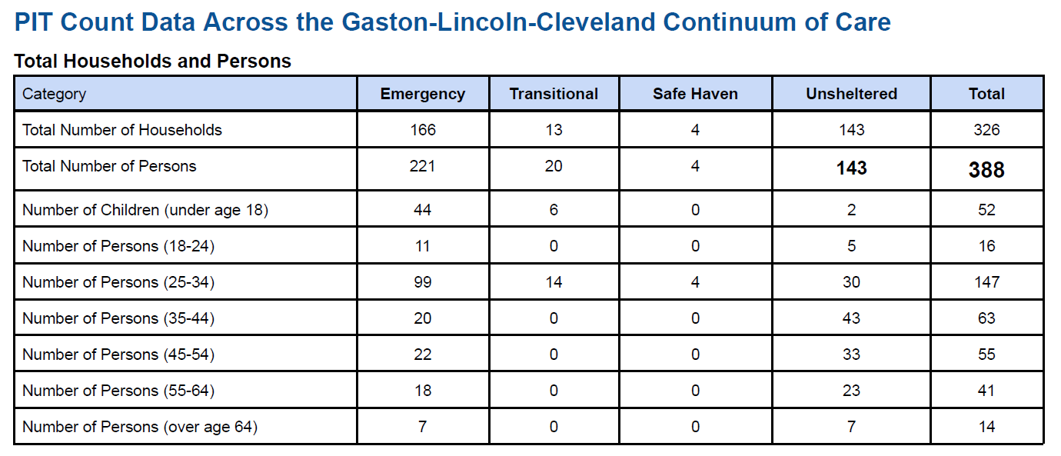
2023 Point in Time Count
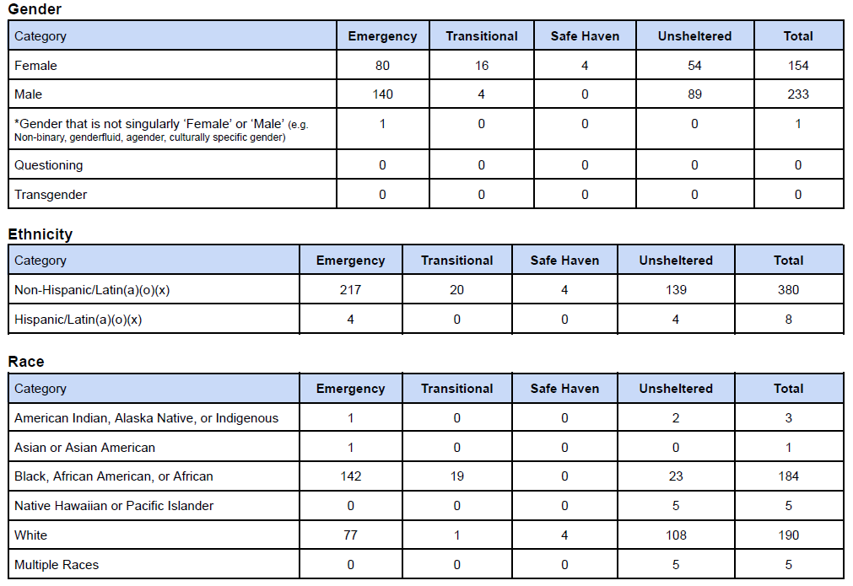
2023 Point in Time Count- Demographics
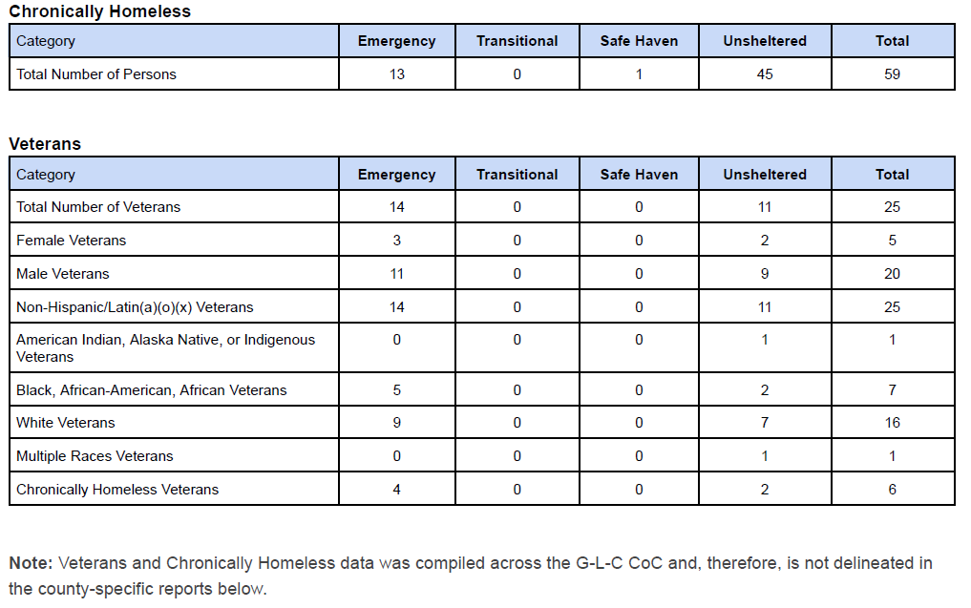
2023 Point in Time Count- Chronic and Veteran
Addressing the emergency shelter and transitional housing needs of homeless persons
The Gaston Lincoln Cleveland (G/L/C) Continuum of Care (CoC) continues to implement and revise its current processes to better address the needs of homeless individuals and families within its program area. The revision to its processes for its emergency shelter and transitional housing are no exception. GLC CoC is in the process of working on its coordinated entry process by ensuring that all agencies have HMIS entry points and that staff at each facility fully understand and are trained on the process. The GLC CoC hopes that, through these efforts, it will promote access and utilization of mainstream programs and optimize self-sufficiency among individuals and families experiencing homelessness. Gastonia is limited in the areas of transitional housing. The current emergency shelter provider is the Salvation Army.
Helping low-income individuals and families avoid becoming homeless, especially extremely low-income individuals and families and those who are: likely to become homeless after being discharged from publicly funded institutions and systems of care (such as health care facilities, mental health facilities, foster care and other youth facilities, and corrections programs and institutions); and, receiving assistance from public or private agencies that address housing, health, social services, employment, education, or youth needs
Various Continuum of Care agencies received CoC NOFA, ESG, ESG-CV, and ESG-CV2 funding and continued to administer those funds during FY2022 to support housing and other services for homeless individuals and families. Some individuals and families transitioning out of publicly funded institutions and systems have limited resources and struggle to secure stable housing. The GLC CoC utilized the Rapid Re-Housing (RRH) Program, however the lack of available, affordable, housing options creates a barrier. The GLC CoC also uses the Emergency Solutions Grant (ESG) to address needs. The resources provided may not fully meet the overwhelming demand for essential services like case management, rental assistance, and homelessness prevention. Amidst these constraints, the GLC CoC continues to work to navigate the complexities of assisting individuals and families who may already be receiving aid from public or private agencies addressing various needs, all while recognizing the persistent vulnerability and instability within our low-income population.
Helping homeless persons (especially chronically homeless individuals and families, families with children, veterans and their families, and unaccompanied youth) make the transition to permanent housing and independent living, including shortening the period of time that individuals and families experience homelessness, facilitating access for homeless individuals and families to affordable housing units, and preventing individuals and families who were recently homeless from becoming homeless again
Gastonia continued its collaborative efforts with the Gaston-Lincoln-Cleveland Continuum of Care (CoC). The CoC continued work with the Gastonia Housing Authority to administer Emergency Housing Vouchers (EHV) to homeless individuals and families in an effort to slow the spread of COVID-19. As FY2022 closed, there were few EHV remaining.
Efforts in assisting homeless individuals and families, with a particular focus on chronically homeless individuals and families, families with children, veterans and their families, and unaccompanied youth, grapple with the challenges of facilitating a transition to permanent housing and independent living. The duration of homelessness remains a persistent concern, with individuals and families struggling to find housing stability. Attempts to navigate the scarcity of affordable housing units for homeless individuals and families, recognizing the stark reality of limited resources. Moreover, the risk of recurring homelessness among those who have recently secured housing continues to be a pressing issue, emphasizing the ongoing vulnerability and instability within our homeless population. Despite these challenges, we remain committed to addressing homelessness within our community, albeit in the face of numerous obstacles.

CR-30 - Public Housing 91.220(h); 91.320(j)
Actions taken to address the needs of public housing
The Gastonia Housing Authority provides permanent housing for very low and extremely low income families through two Section 8 programs and applicants can apply for one or both of the programs, providing the waiting lists are open.
- The Housing Choice Voucher (HCV) Program
- The Project-Based Voucher (PBV) Program
HCV provides vouchers to qualified applicants which allow families to locate affordable housing throughout Gaston County. The waitlist for HCV’s is currently at 3075 households. GHA has 1799 HCV's; 100 are prioritiezed for Non-Elderly Disabled (NED). 37 are Emergency Housing Vouchers (EHV) which prioritiezes homelessness, at-risk of homelessness and/or domestic violence. Those seeking to access EHV must come through one of the following referral partners
- The Salvation Army
- The Hope Youth Network
- Family Promise
- HealthNet Gaston
- Kintegra Health
- Monarch
- The Shelter of Gaston County
- Partners Health Management
Project-Based Vouchers (PB) provide assistance at specific apartment communities in Gaston County. Below are a list of the communities that have project-based voucher assistance provided by the Gastonia Housing Authority.
- Cameron Courts
- Weldon Heights
- Mountain View
The following properties are designated for residents ages 62 and older:
- Linwood Terrace
- Gateway Village
- Loftin at Montcross
- Dallas High School Apartments (age 62 and older OR age 55 and older AND in need of supportive services)
The Belmont Housing Authority provides permanent housing for eligible low-income elderly individuals and persons with disabilities through two Public Housing Properties.
- Flowers Court
- Myrtle Terrace
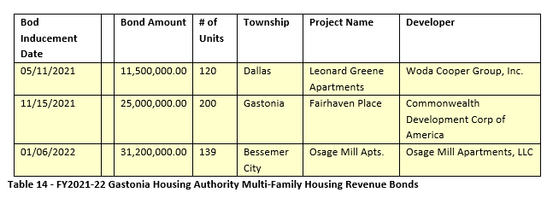
EHV Utilization
GHA Multi-Family Housing Revenue Bonds
Actions taken to encourage public housing residents to become more involved in management and participate in homeownership
Due to staff and increased inquiries and request for assistance, and current housing market conditions, there are limited opportunities for public housing residents to become involved with homeownership. The City of Gastonia is working to resume it's 12-month program that will allow public housing residents the opportunity to actively engage interested persons.
Actions taken to provide assistance to troubled PHAs
Neither the Gastonia Housing Authority nor the Belmont Housing Authority are not considered troubled Public Housing Authority (PHA), therefore this category does not apply.

CR-35 - Other Actions 91.220(j)-(k); 91.320(i)-(j)
Actions taken to remove or ameliorate the negative effects of public policies that serve as barriers to affordable housing such as land use controls, tax policies affecting land, zoning ordinances, building codes, fees and charges, growth limitations, and policies affecting the return on residential investment. 91.220 (j); 91.320 (i)
Staff continues to work with other departments and citizens to determine issues that serve as barriers to affordable housing. In 2019, the City of Gastonia conducted an Analysis of Impediments to identify barriers to fair and affordable housing. This is an ongoing process, and staff works with other departments to comply with other regulatory policies to determine the best course of action to eliminate or minimalize the perceived barrier(s).
In June 2023, the City of Gastonia initiated efforts to complete an Analysis of Impediments with completion anticipated in April/May of 2024. Additionally, the City of Gastonia is currently undertaking an affordable housing study to development a plan to address affordable housing.
Actions taken to address obstacles to meeting underserved needs. 91.220(k); 91.320(j)
The City of Gastonia makes efforts to educate individuals and families on the components of Fair Housing. The City continues to look at innovative ways to conduct Fair Housing education. More information about our efforts regarding Fair Housing can be found under the section titled “Identify actions taken to overcome the effects of any impediments identified in the jurisdictions analysis of impediments to fair housing choice”.
City General Funds are used to create an assistance fund that helps with customer utility costs. This is called the Gastonia Electric Assistance Resource (GEAR) Program. Very low and low-income families that meet program requirements and apply are eligible to receive a monthly stipend which is applied to the utility balance of $25-$35.
The City of Gastonia applied for a Community Project Funding Grant to increase opportunity for the underserved population of Gastonia by esidents to receive housing rehabilitation assistance. In addition, Gastonia has implemented policy revisions to allow for increased assistance through Direct Homeownership Assistance (DHA) and provide increased incentives to developers to produce more units in multi-family housing projects to accomodate low- to moderate- income residents.
Actions taken to reduce lead-based paint hazards. 91.220(k); 91.320(j)
The City currently assesses pre-1978 housing for the homebuyers and the owner-occupied rehabilitation program. Pre-and post testing and assessments are conducted as needed. In addition, efforts are made to educate program participants on the hazards of lead by providing resource materials at the time of program application.
Actions taken to reduce the number of poverty-level families. 91.220(k); 91.320(j)
In December 2022, the City of Gastonia conducted an affordable housing study. Final recommendations are anticipated in November 2022, and will provide opportunity for increased housing choice options to further reduce the number of povety-level families.
Actions taken to develop institutional structure. 91.220(k); 91.320(j)
The two most notable actions continue with the Community Housing Development Organization (CHDO) and the Lead Agency for the Continuum of Care. Belmont Community Development Corporation is the designated CDHO for a project on Norment Ave. in Gastonia. The City of Gastonia has worked closely with Belmont CDC in providing technical assistance. HealthNet Gaston is the Lead Agency for the Continuum of Care and the City of Gastonia is providing technical assistance as needed to help guide the continued structural improvement of the Continuum of Care.
Actions taken to enhance coordination between public and private housing and social service agencies. 91.220(k); 91.320(j)
The City of Gastonia works in partnership with Community Organizations, Public Agencies, sub-recipients, and contractors. The City of Gastonia has not had a designated CHDO in the past few years after the end of the relationship with the prior agency with the CHDO designation, Reinvestment in Communities of Gaston County, Inc. (now known as Our Neighbors, Inc.). The City of Gastonia will now be working with Belmont Community Development Corporation as a CHDO for future projects.
HealthNet Gaston served in the capacity of subrecipient administering the Tenant-Based Rental Assistance Program in Gaston County.
The City of Gastonia continues to partner with Habitat for Humanity of Gaston County to increase the stock of homeownership opportunities for low-income families by providing property and/or site preparation work for new housing construction. During this fiscal year, through the collaborative efforts, Habitat will partner with the City of Gastonia for homeownership candidates for their newest development, Dixon Village.
Private for-profit partners include multiple financial institutions, contractors and other corporations.
The City of Gastonia, in continued collaboration with the Gaston-Lincoln-Cleveland Continuum of Care, maintains its commitment to fostering community-wide coordination among public agencies, private housing providers, and social service agencies to address affordable housing and guide those in need towards available services. These ongoing efforts have recently included a strategic partnership between the Gaston-Lincoln-Cleveland Continuum of Care, the Gastonia Housing Authority, and private housing providers to implement and administer Emergency Housing Vouchers (EHV) made available through the American Rescue Plan Act (ARPA).
The City of Gastonia collaborated with the United Way of Gaston County for utility rental assistance and the Salvation Army for rental assistanceFo Utility and Rental assistance programs,reaffirming their commitment to assist the low- to moderate-income population with vital services.
Identify actions taken to overcome the effects of any impediments identified in the jurisdictions analysis of impediments to fair housing choice. 91.520(a)
To better education residents about fair housing and to increase the opportunity for greater housing choice, staff made efforts to actively provide education to schools concerning fair housing. Due to COVID, these methods have been temporarily suspended. In April 2023, as part of Fair Housing Month, the City of Gastonia organized an educational event with a special focus on school-aged children aged 5 to 15 participating in an after-school program. This initiative aimed to raise awareness and educate young minds about fair housing principles. Impressively, the event successfully reached and educated approximately 27 children, fostering a culture of fairness and inclusivity from a young age.
The City of Gastonia upholds its commitment to fair housing by maintaining a dedicated Fair Housing information phone line. This resource serves as a screening tool to assist individuals and families who suspect they may have encountered housing discrimination. Importantly, this line also extends its reach to address a spectrum of housing-related inquiries, providing valuable referrals to legal assistance, non-profit organizations, and other relevant resources. On average, call volume ranges from 15 to 17 calls per weekwith less than 1% of all callers experiencing actual fair housing violations.

CR-40 - Monitoring 91.220 and 91.230
Describe the standards and procedures used to monitor activities carried out in furtherance of the plan and used to ensure long-term compliance with requirements of the programs involved, including minority business outreach and the comprehensive planning requirements

Upon completion and close-out of an activity, a monitoring case file is established that denotes the affordability period and the compliance requirements for the activity. To ensure long-term compliance, the project is added to the monitoring schedule and projects are monitored as required. All activities are conducted in accordance with program regulations and current monitoring policies. The City of Gastonia has a structured set of standards and procedures to oversee activities aligned with its strategic plan and ensure ongoing compliance with program requirements. This approach involves routine program assessments, thorough documentation, and diligent progress tracking.
Minority business outreach efforts include support and intentional inclusion of Minority Business Enterprise (MBE) and small business in the competitive bid process. To date the City of Gastonia does not have a minority recruitment program in place. Gaston County government has implemented a program to conduct outreach to miniority businesses. The City of Gastonia supports Gaston County government's programming efforts where possible.
Comprehensive planning requirements include intermittent reviews of the Consolidated Plan in preparing for Annual Plan preparation in coorelation with current City's strategic plan.

Citizen Participation Plan 91.105(d); 91.115(d)
Describe the efforts to provide citizens with reasonable notice and an opportunity to comment on performance reports.
Efforts to provide citizens with reasonable notice and an opportunity to comment on performance reports are done in accordance with the current Citizen Participation Plan,revised 2019. A 30-day public comment period is established for both the Annual Action Plan and the Consolidated Annual Performance Evaluation Report. A minimum 10-day advance notice is published notifying citizens of the opportunity to participate, review and/or comment along with the date, time, and location to review the plans and/or attend the public hearings. Notices are published in the local newspaper and on the City's website. In addition, the Citizens Advisory Board consists of 1 member selected by the Council to represent each of the City’s six wards or other areas deemed appropriate by the Council. Additionally, there shall be two at-large members appointed by Gaston County Commission to represent the county’s unincorporated areas. Board members are extended the opportunity to review proposed plans and activities and comment accordingly. The board meets quarterly and is notified of public hearings for all plans.

CR-45 - CDBG 91.520(c)
Specify the nature of, and reasons for, any changes in the jurisdiction’s program objectives and indications of how the jurisdiction would change its programs as a result of its experiences.
COVID-19 impacts are declining and opportunity to expand programming continues to increase. Current market volatility continues to impact affordable housing for all citizens. Low-and moderate-income citizens continue to have a greater level of difficulty in acquiring or maintaining properties. Staff continues to explore options to best benefit low- to moderate-individuals and families impacted by current market conditions.
The City of Gastonia does not plan to make any significant modifications to the program objectives.
Does this Jurisdiction have any open Brownfields Economic Development Initiative (BEDI) grants?
No
[BEDI grantees] Describe accomplishments and program outcomes during the last year.

CR-50 - HOME 24 CFR 91.520(d)
Include the results of on-site inspections of affordable rental housing assisted under the program to determine compliance with housing codes and other applicable regulations
Please list those projects that should have been inspected on-site this program year based upon the schedule in 24 CFR §92.504(d). Indicate which of these were inspected and a summary of issues that were detected during the inspection. For those that were not inspected, please indicate the reason and how you will remedy the situation.
Gastonia has opted for a rigorous monitoring regimen, wherein they conduct annual reviews of all properties. This approach guarantees ongoing compliance of units and swift resolution of any concerns, preventing lengthy periods of unawareness among staff. In the fiscal year 2022-23 monitoring process, all HOME projects were in compliance, except for four. The staff is actively collaborating with the recipients of funding to address these non-compliance issues. They are committed to offering technical support and guidance to resolve these matters and, if required, will employ enforcement measures to ensure compliance. As shown below, seven properties failed the initial HQS Inspection. The reasons for initial failure can be condensed down to “non-functional components” and/or “failed components”.
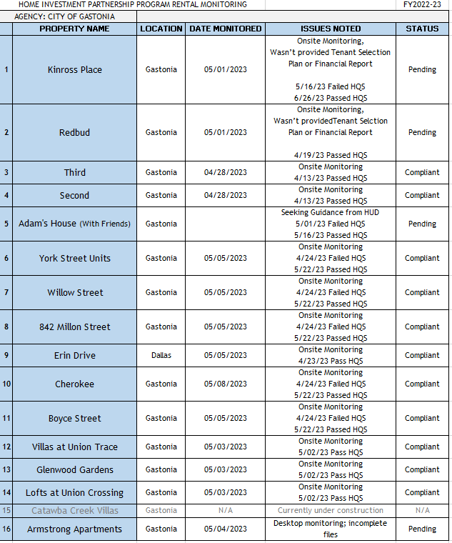
HOME Monitoring ÿ HQS
Provide an assessment of the jurisdiction's affirmative marketing actions for HOME units. 24 CFR 91.520(e) and 24 CFR 92.351(a)
The City of Gastonia continues to support and encourage the use of affirmative marketing for HOME-assisted units. These efforts help to support the opportunity for fair and equal housing for all persons within the community.
The current affirmative marketing plan addresses how the City will effectively market housing and offer equal housing opportunities regardless of race, color, national origin, religion, sex, familial status, or disability. Affirmative marketing actions helps owners/agents (respondents) effectively market the availability of housing opportunities to individuals of both minority and non-minority groups that are least likely to apply for occupancy. Currently the City of Gastonia makes every effort to meet this requirement within all of its housing activities, by providing transparency of all requirements, making information accessible and providing the same information and opportunity to all interested participants.
Refer to IDIS reports to describe the amount and use of program income for projects, including the number of projects and owner and tenant characteristics
$12,736.76 of the HOME program income was spent on Down Payment Assistance for two individuals. One buyer was a single, non-elderly person who identified their race as "Black or African American". The other buyer was an elderly person who identified their race as "White". $35,195.76 of the HOME program income was spent on Tenant Based Rental Assistance. Of the families receiving assistance through TBRA, four families identified their race as "Black or African American", two families identified their face as "White", and two families identified their race as "Asian". One family identified "Hispanic" as their ethnicity. Seven of the families receiving assistance through TBRA were within 0-30% of the AMI. One family recieving assistance through TBRA were within 30-50% of AMI.
Describe other actions taken to foster and maintain affordable housing. 24 CFR 91.220(k) (STATES ONLY: Including the coordination of LIHTC with the development of affordable housing). 24 CFR 91.320(j)

CR-58 – Section 3
Identify the number of individuals assisted and the types of assistance provided

Total Labor Hours | CDBG | HOME | ESG | HOPWA | HTF
Total Number of Activities | 0 | 1 | 0 | 0 | 0
Total Labor Hours | 0 | 20,789
Total Section 3 Worker Hours | 0 | 4,392
Total Targeted Section 3 Worker Hours | 0 | 0
Table 14 – Total Labor Hours

Qualitative Efforts - Number of Activities by Program | CDBG | HOME | ESG | HOPWA | HTF
Outreach efforts to generate job applicants who are Public Housing Targeted Workers |  | 1
Outreach efforts to generate job applicants who are Other Funding Targeted Workers. |  | 1
Direct, on-the job training (including apprenticeships).
Indirect training such as arranging for, contracting for, or paying tuition for, off-site training.
Technical assistance to help Section 3 workers compete for jobs (e.g., resume assistance, coaching).
Outreach efforts to identify and secure bids from Section 3 business concerns.
Technical assistance to help Section 3 business concerns understand and bid on contracts. |  | 1
Division of contracts into smaller jobs to facilitate participation by Section 3 business concerns.
Provided or connected residents with assistance in seeking employment including: drafting resumes,preparing for interviews, finding job opportunities, connecting residents to job placement services.
Held one or more job fairs.
Provided or connected residents with supportive services that can provide direct services or referrals.
Provided or connected residents with supportive services that provide one or more of the following: work readiness health screenings, interview clothing, uniforms, test fees, transportation.
Assisted residents with finding child care.
Assisted residents to apply for, or attend community college or a four year educational institution.
Assisted residents to apply for, or attend vocational/technical training.
Assisted residents to obtain financial literacy training and/or coaching.
Bonding assistance, guaranties, or other efforts to support viable bids from Section 3 business concerns.
Provided or connected residents with training on computer use or online technologies.
Promoting the use of a business registry designed to create opportunities for disadvantaged and small businesses.
Outreach, engagement, or referrals with the state one-stop system, as designed in Section 121(e)(2) of the Workforce Innovation and Opportunity Act.
Other.
Table 15 – Qualitative Efforts - Number of Activities by Program

Narrative
The construction of one (1) multi-family housing devleopment was funded with HOME Investment Partnerships Program funds was completed during FY2022 and subsidized with North Carolina Low-Income Housing Tax Credits (LITHC). Section 3 was applicable to the project.

